

Draw It or Lose It

CS 230 Project Software Design
Version 1.0

Table of Contents

CS 230 Project Software Design 1
Table of Contents 2
Document Revision History 2
Executive Summary 3
Requirements 3
Design Constraints 3
System Architecture View 3
Domain Model 3
Evaluation 4
Recommendations 5

Document Revision History

Version | Date | Author | Comments
1.0 | 07/19/2026 | Garrett Mandeville | Initial design document for Draw It or Lose It web application.

Instructions
Fill in all bracketed information on page one (the cover page), in the Document Revision History table, and below each header. Under each header, remove the bracketed prompt and write your own paragraph response covering the indicated information.

Executive Summary

The Gaming Room requires a transition of their Draw It or Lose It Android application into a robust, web-based distributed platform to support multiple concurrent users and teams. The proposed solution is a centralized, in-memory game engine built in Java that serves as the "single source of truth" for game states. This application utilizes a Singleton pattern to manage the game service, ensuring strict data integrity and memory efficiency. By refactoring the core logic to use an Entity hierarchy and the Iterator pattern for data management, we provide a scalable, maintainable foundation that allows the client to expand functionality while ensuring game and team names remain unique across all sessions.

Requirements
Business Requirements:
- Scalability: The game must support one or more teams and multiple players per team to meet the client's user engagement goals.
- Uniqueness: Game, team, and player names must be checked against existing instances to prevent duplicates, ensuring a clear and organized experience for the players.
Technical Requirements
- Singleton Constraint: Only one instance of the game service can exist in memory at any given time to maintain a centralized, single source of truth for the game state.
- Identification: All entities (Game, Team, Player) must possess unique system identifiers to allow for efficient backend lookup and data management.

Design Constraints

The development of this application within a web-based, distributed environment introduces two primary constraints:
- State Consistency: Because the application is web-based, it will eventually support concurrent user requests from multiple devices. Relying on a Singleton pattern for the backend requires careful handling of synchronization to prevent race conditions where two users might attempt to claim the same team name simultaneously.
- Resource Management: Running the game engine in-memory provides high performance, but it limits horizontal scalability. Future development must account for the transition from an in-memory singleton to a distributed database system as the user base grows, ensuring that the software architecture does not become a bottleneck.

System Architecture View

Domain Model

The UML Domain Model serves as the blueprint for our object-oriented architecture. The central component is the GameService class, which manages the lifecycle of Game objects. Every Game object maintains a list of Team objects, and each Team object maintains a list of Player objects.
The model leverages three key Object-Oriented principles:
- Inheritance: The Entity base class is the foundation for Game, Team, and Player. By centralizing id and name attributes, we ensure that every object in the system adheres to a consistent structure, reducing code redundancy.
- Singleton Pattern: The GameService uses a private constructor and a static instance to guarantee that only one engine controls the game state, fulfilling the critical constraint of a single memory instance.
- Iterator Pattern: This is used in the addGame, addTeam, and addPlayer methods. By using the Iterator interface, we traverse our collections safely to validate uniqueness without exposing the underlying data structures to external modification, ensuring data integrity.

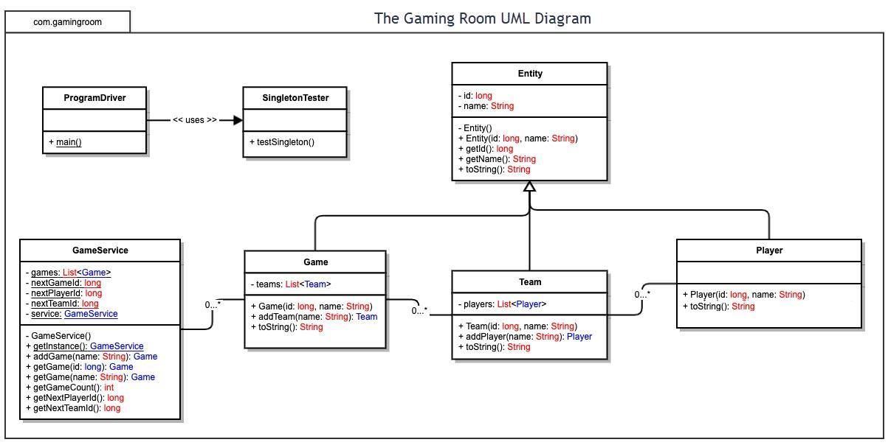

Evaluation

Development Requirements | Mac | Linux | Windows | Mobile Devices
Server Side | Mac computers can host servers, but Apple hardware is very expensive. Because of the high cost, it is not the most common choice for hosting large web applications. | Linux is the industry standard for web servers. It is highly stable, and the operating system is open-source, making it the most cost-effective choice for hosting. To address the client's goal of supporting thousands of concurrent players, Linux servers can be easily deployed across scalable cloud hosting tiers, such as AWS or Google Cloud. By utilizing load balancers, incoming traffic can be distributed dynamically across multiple Linux instances to maintain performance during peak traffic. | Windows Server is very popular in the corporate world, but it requires the client to pay high licensing fees for the operating system and user access. While it also fully supports cloud scalability and load balancing, via platforms like Microsoft Azure, the cost per server instance is much higher than Linux when attempting to scale horizontally for thousands of players. | Mobile devices like smartphones and tablets do not have the hardware or operating systems designed to host web servers. They cannot be used for server-side hosting.
Client Side | Mac provides a great environment for developers. Testing on a Mac ensures the web application looks and works correctly on Apple's Safari browser. | Linux is great for open-source development. A web development team can easily use it to build and test the website using standard browsers like Firefox. | Windows is the most common operating system for everyday users. Developers must spend time testing the game on multiple browsers like Chrome, Edge, and Firefox to ensure it works for everyone. | For mobile devices, developers must use "responsive design." This means writing HTML and CSS so the website shrinks and adapts to small touch screens instead of a mouse and keyboard.
Development Tools | There are many great coding tools and IDEs for Mac, such as IntelliJ IDEA, Eclipse, and Visual Studio Code. We will use Java for the backend and HTML, CSS, and JavaScript for the frontend. Because these languages are cross-platform, a single web development team can build the client in these IDEs without needing multiple teams. | Linux supports mostly free, open-source IDEs—like Visual Studio Code, Eclipse, and IntelliJ IDEA Community Edition—for writing Java, HTML, CSS, and JavaScript. This helps keep project costs down because there are no expensive software licenses to buy. | Windows has powerful tools like Microsoft Visual Studio for web and Java development. While great for development, these enterprise tools can sometimes cost a lot of money in licensing fees per developer. | While native mobile app development requires platform-specific tooling, such as Xcode for iOS and Android Studio for Android, the client wants a web-based HTML/CSS/JavaScript game, meaning we can bypass these specialized environments. The same single web development team can build the site to work on mobile browsers, eliminating the need for separate iOS and Android teams..

Recommendations

- Operating Platform: I recommend Linux, specifically a distribution like Ubuntu Server, as the operating platform. Linux provides a robust, POSIX-compliant environment that supports high portability, allowing The Gaming Room to easily expand the Draw It or Lose It backend to various hardware architectures and cloud computing environments as the user base grows.
- Operating Systems Architectures: Linux utilizes a monolithic kernel architecture augmented by dynamically loadable kernel modules (DLKMs), which provides both high performance and flexibility. Its advanced process management and preemptive scheduling ensure that the Java game engine's background processes (daemons) run smoothly, providing a highly stable server environment even under heavy concurrent player load.
- Storage Management: To ensure data durability, we must transition from volatile main memory to non-volatile secondary storage. I recommend using a relational database management system, like MySQL, layered over the Linux file system, such as ext4,. This abstracts the physical disk management into logical storage units, ensuring that player accounts and scores are permanently and safely recorded even if the server restarts.
- Memory Management: The Linux operating system will manage the application's physical RAM using virtual memory and demand paging, allocating space dynamically. While the Java Virtual Machine handles application-level memory through automatic garbage collection, the software must still explicitly release old game sessions. This prevents virtual memory exhaustion and ensures the OS does not have to heavily swap pages to disk, which would degrade game performance.
- Distributed Systems and Networks: To allow communication between different client platforms and the central server, the system will use a client-server distributed architecture operating over the TCP/IP network stack. The web browser and server will communicate via a REST API. To manage network dependencies and fault tolerance, such as latency, packet loss, or temporary connection outages, the client software will implement automatic reconnection logic, like exponential backoff, to restore session states smoothly without dropping users.
- Security: To protect against both network and program threats (Silberschatz et al., 2009), a multi-layered security approach is necessary. At the operating system level, process isolation and strict access control lists (ACLs) will protect server resources. At the network and application levels, we will use HTTPS/TLS encryption to secure data in transit, implement secure digital tokens, such as JWT, for safe, stateless user authentication, and strictly sanitize all user inputs to prevent malicious code injection.

References
Google. (2026). Gemini (July 2026 version) [Large language model]. https://gemini.google.com
Silberschatz, A., Galvin, P. B., & Gagne, G. (2009). Operating system concepts (8th ed.). John Wiley & Sons, Inc. https://learning.oreilly.com/library/view/operating-system-concepts/9780470128725/silb_9780470128725_oeb_c15_r1.html#h4

